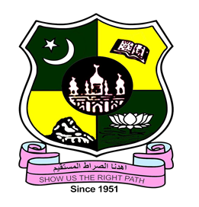**JAMAL MOHAMED COLLEGE (AUTONOMOUS)**

Accredited with A++ Grade by NAAC (4th Cycle) with CGPA 3.69 out of 4.0

(Affiliated to Bharathidasan University)

TIRUCHIRAPPALLI – 620 020

Certificate

This is to certify that Dr./Mr./Ms.**«NAME»Designation**of**«DEPARTMENT»**has participated in **A Five-Day Faculty Development Programme,** jointlyorganized by **Department Name**, **Collaborative Institution (if needed)** and **Internal Quality Assurance Cell** of our college from 05.06.2024 to 09.06.2024.

**Head of the Department Coordinator - IQAC PRINCIPAL**